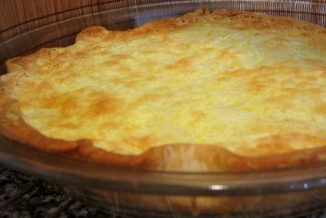
Quiche with Brie

Prep time :20 min

Cook time : 40 min

Ingredients :

-120g (4.5 oz) wheel Brie (do not remove crust)
-100g (3.6oz) Bacon
-3 large eggs, 20cl (6.8 fl oz) sour cream, 10 cl (3.4 fl oz) milk
-shortcrust pastry : 100g (3.5oz) butter, 200g (7oz) plain flour, 10cl (3.4 fl oz) water, pinch of salt

Preparation :

Preheat oven to 180°C (350°F)
Form pastry into a disc for a round tart
Cut cheese into thin slices and put them onto pastry.
Add small pieces of bacon
Beat together milk, eggs and sour cream
Salt and pepper
Turn this mix out on to pastry
Bake in oven about 40mn to 180°C.
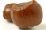
Serve with a salad dressed with hazelnuts oil
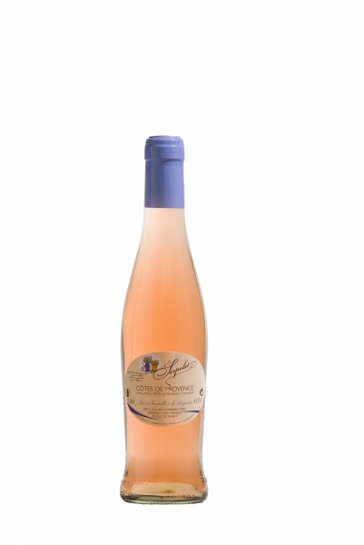

Pouilly Fumé, côte de Provence.

Bon Appétit !

